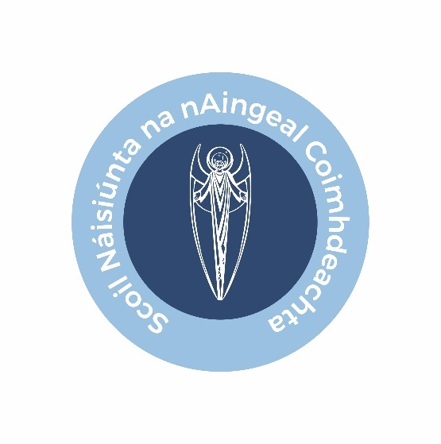

# Registration for First Holy Communion

If you wish your child to celebrate their First Holy Communion this school year, please complete and return this registration form no later than **Friday 11 November**. Forms can be returned by email to [admin.office@guardianangels.ie](mailto:admin.office@guardianangels.ie) or printed and returned to your class teacher.

Please note, the information contained in this form will be shared with the Church of the Guardian Angels to register your child for their First Holy Communion. The parish will use the mobile contact number provided in this form to directly share updates and information on key dates and events related to your child’s First Holy Communion.

I would like to register my child ________________________________

In ___________________________ (teacher’s name) class to celebrate their First Holy Communion.

Child’s date of birth__________________

Parent/guardian signature __________________________________

Parent/guardian mobile number _____________________________